23 Kids with broken hearts… got ‘em fixed!

On October 18, 2003 Dr. William Novick , founder of the International Children’s Heart Foundation based at the University of Tennessee in Memphis and his 15 member team of volunteer medical professional depart from the States to Minsk, the Capital of the Republic of Belarus.

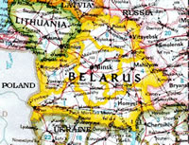

Upon their arrival our exhausted travel wary team, were warmly welcomed by fellow Rotarians of the Rotary Club of Minsk. The Rotary Club of Minsk were the organizers of this mission and the caretakers of our team ensuring they were provided with safe non-contaminated food and water, comfortable secure lodging and entertainment during their stay in Belarus.

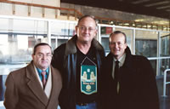

The team arrived home safe and sound late on the evening of November 2nd as few days longer than originally anticipated.

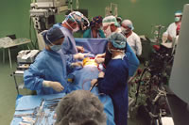

Twenty-three children were operated on during this highly successful mission. All are doing very well. The lives of these children saved during this humanitarian mission have been dedicated to the memory of the Firefighters who gave their lives so others could live during the horrific events of September 11, 2001. Please visit the following website http://www.babyhearts.com meet the kids whose lives we helped save!

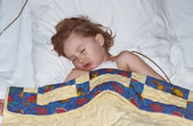

The magic of Rotary certainly was event in this mission. Rotarians from our District 7980, District 7470 of New Jersey both of our Gift of Life Foundations and the Rotary Club of Minsk representing District 2230 joined hands with the International Children’s Heart Foundation (ICHF) to save the lives of children and we certainly did!

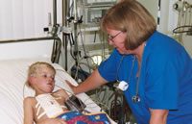

The people of Belarus are wonderful, very warm, gracious and so appreciative of any help from the outside world. The humanitarian needs are tremendous with so many orphanages and kids being born with surgically correctable congenital abnormalities. It is estimated 900 babies are born annually with surgically repairable congenital heart defects the majority are attributed to the long term effects of the Chernobyl Atomic Energy Station explosion 17 years ago and the effects of long term poverty. At present, there is an estimated 6000 children on the waiting list for life saving heart surgery, who will die during their childhood if the procedure is not performed.

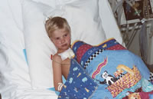

There are so many kids still with broken hearts… yet to be fixed. Please consider supporting our District’s Gift of Life Foundation so we together can save a record number of kids in 2004!

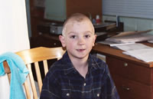

I will summarize my request, should you have any questions and/or desire additional information please feel free to email or call (203-281-7540) at any time.

Kids with broken hearts…. let’s fix some more!

Project: District 7980 Gift of Life. Provide cardiac surgery in children with surgically repairable congenital heart defects.

Anticipated number of children under going surgery: 20-30 per mission!

Country: Republic of Belarus

Organizers of this Mission: Rotary Club of Minsk

When: Two – Five missions pending upon financial support available

Participants:

International Children’s Heart Foundation (ICHF)
Founder: William Novick, MD

ICHF provides a trained volunteer medical team comprised of pediatric cardiac surgeons, nurses and medical support professionals required to perform cardiac surgery on children with life threatening congenital heart defects. ICHF provides all of the equipment, surgical instruments, medications and consumables required to perform these procedures. Training of the medical staff in Belarus to perform these procedures is also a very important part of this mission.

There are no travel costs incurred by the medical team members. Funds are needed for travel expenses, food and lodging. The trips are usually two weeks in length with 9 to 11 operating days. Depending on the destination and team size, the number of cases performed range from 15 to 40.

Reference: http://www.babyhearts.com

Please direct your donations to:
Gift of Life Corporation District 7980
C/o Henry Scoop
21 Court St.
W. Haven, CT 06516-5021

Lynda Hammond
Rotary Club of Hamden

